Practical 08:

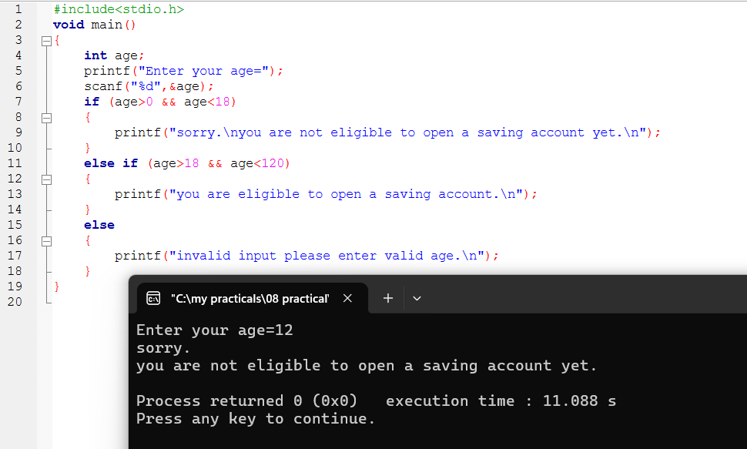

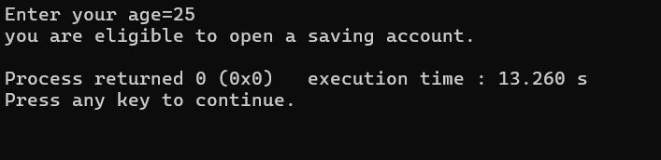

8-i:

8-ii,iii:



